**Car Selling Platform Help Document**

This is help document which provides some information regarding the needed things to run this project.

Required installation in Angular:-

1. Sweet alert is needed to be installed. **“Npm install sweetalert2.**
2. Bootstrap/mdbootstrap should be installed.
3. Angular Material should be installed. **“ng add @angular/material” / "npx ng add @angular/material.**

**Here are the steps through which user can explore the application.**

**Note:** This is a fully Authenticated project. You need to register and signin before using it. Angular Guard has been used to secure the router link’s. Only authenticated user can access the router links. If you are using it for the first time and you want to explore admin side, you need to register as a admin. For that while registering use username as “***admin@123”***  . after that you can login as a admin.

1. Run the application on localhost:8081

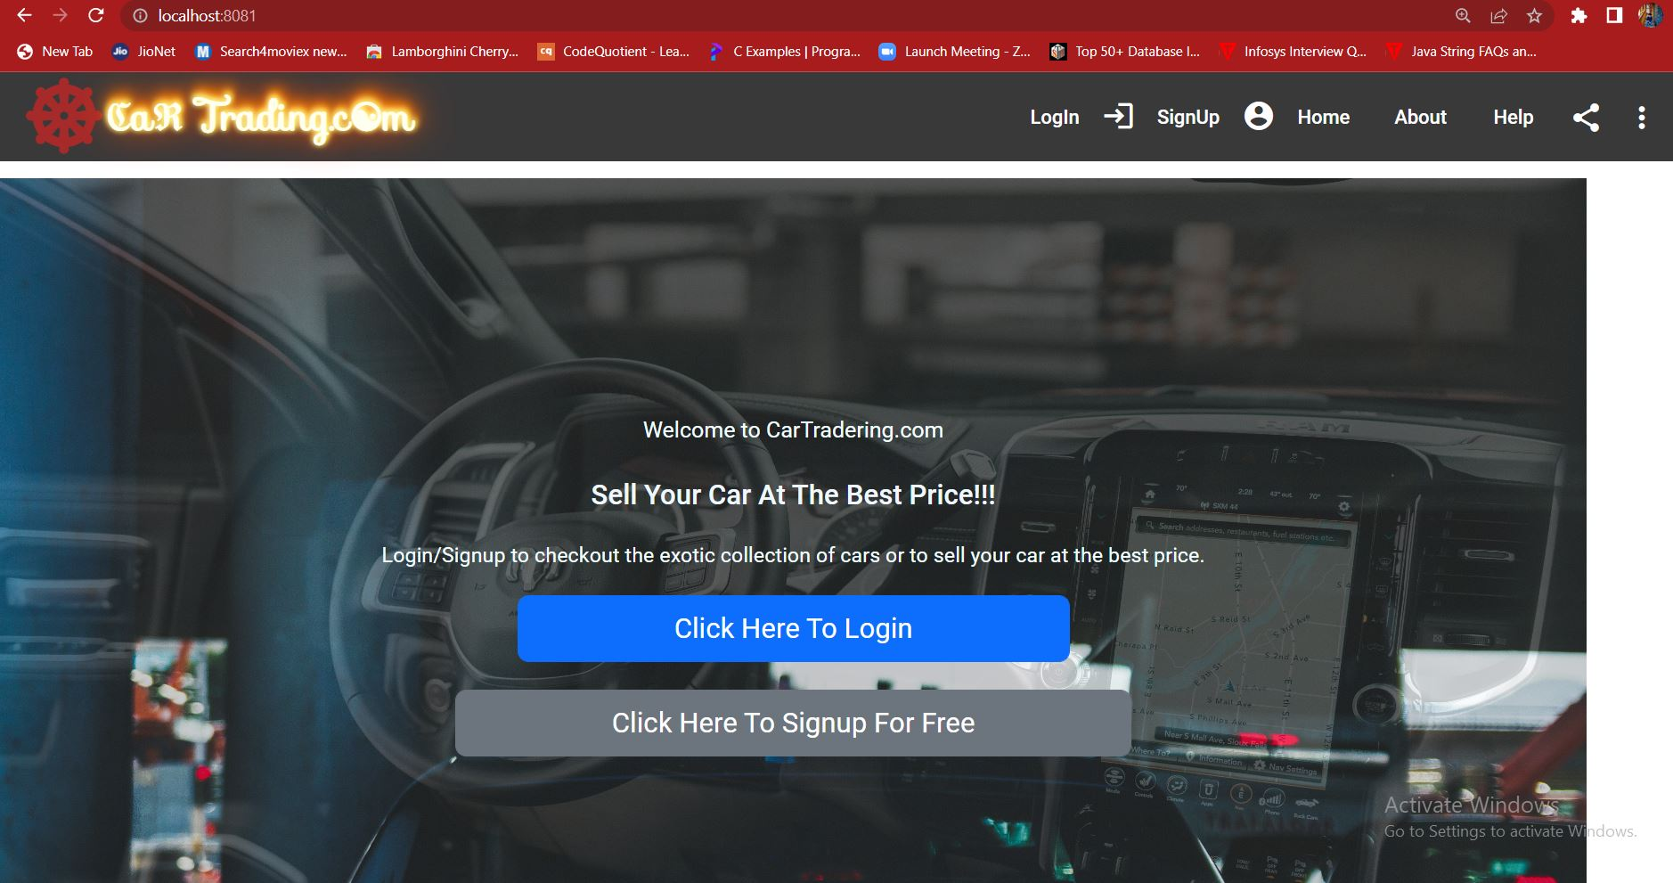

1. Signup and remember your username and password. To use admin side, First sign up and use username as ***“admin@123”*** after that login with admin@123 username. For normal user you can use any of the username.

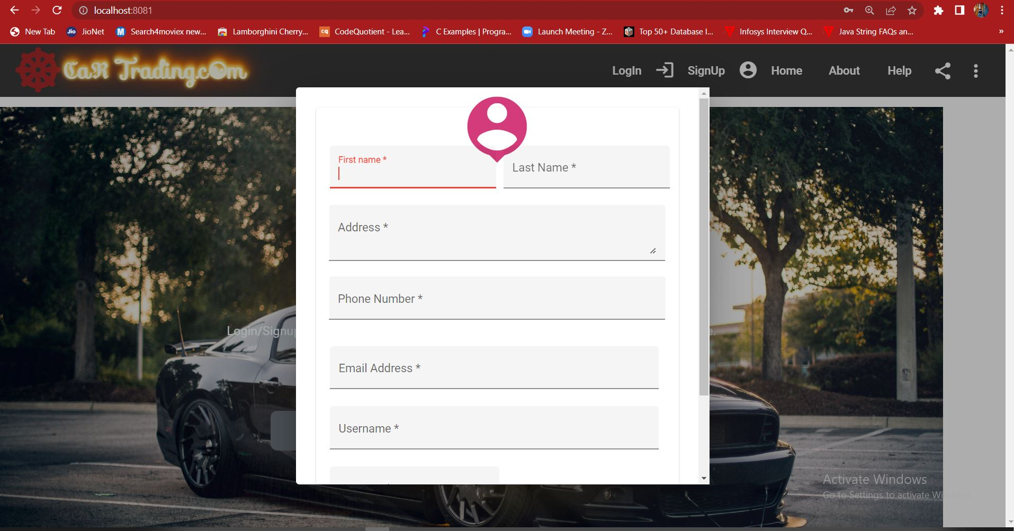

1. Now login. 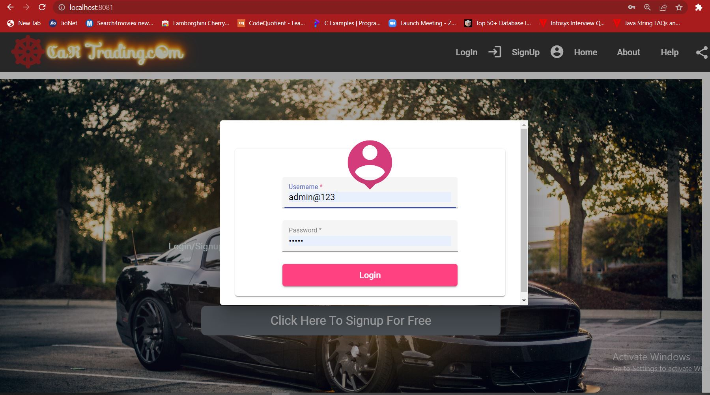
2. After login as a normal user you will land on this welcome page. Click on sell Car>add car details>submit.

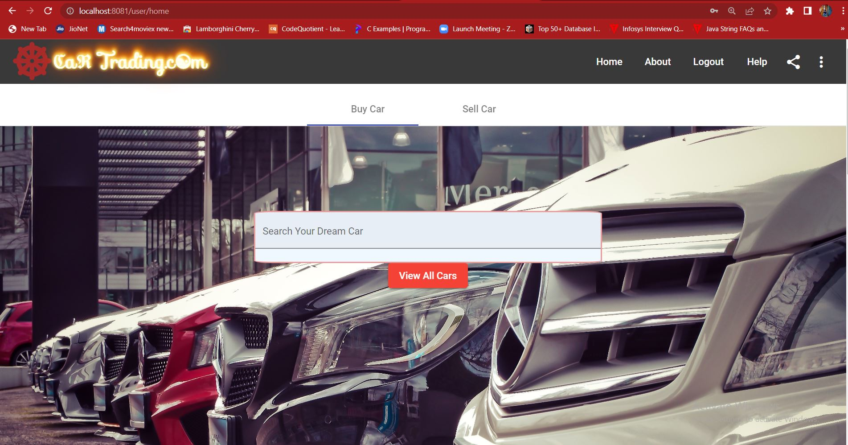

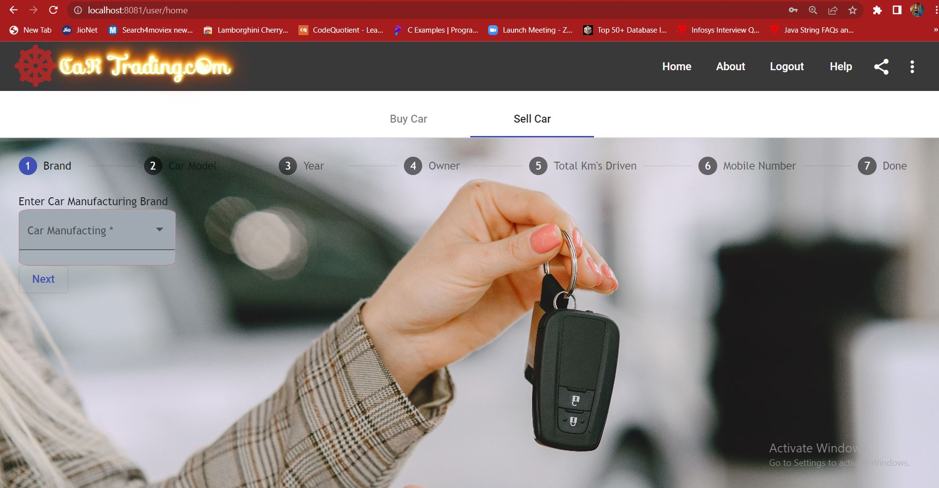

After submitting you car details, your car will be listed on the admin side. Admin can accept or reject your car offer. You can also view your car status from menu button.

5. User can view their applied car status from menu.

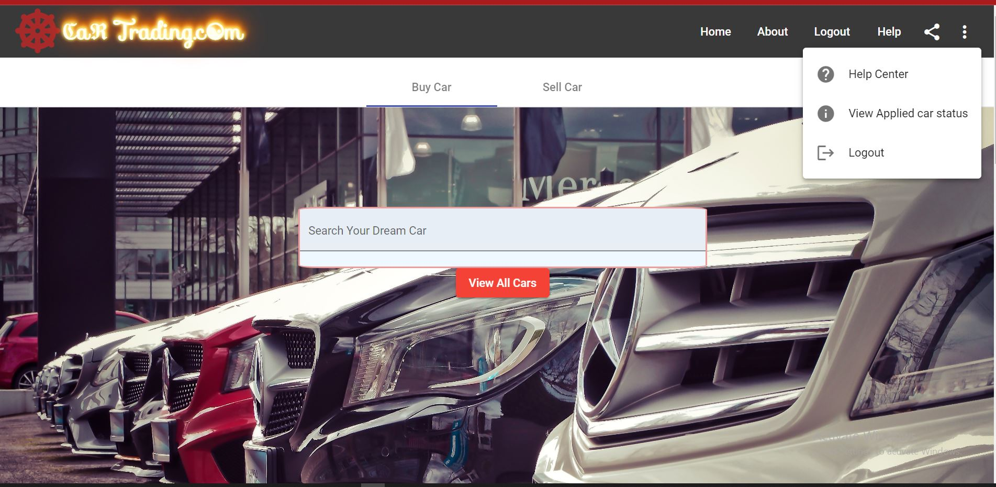

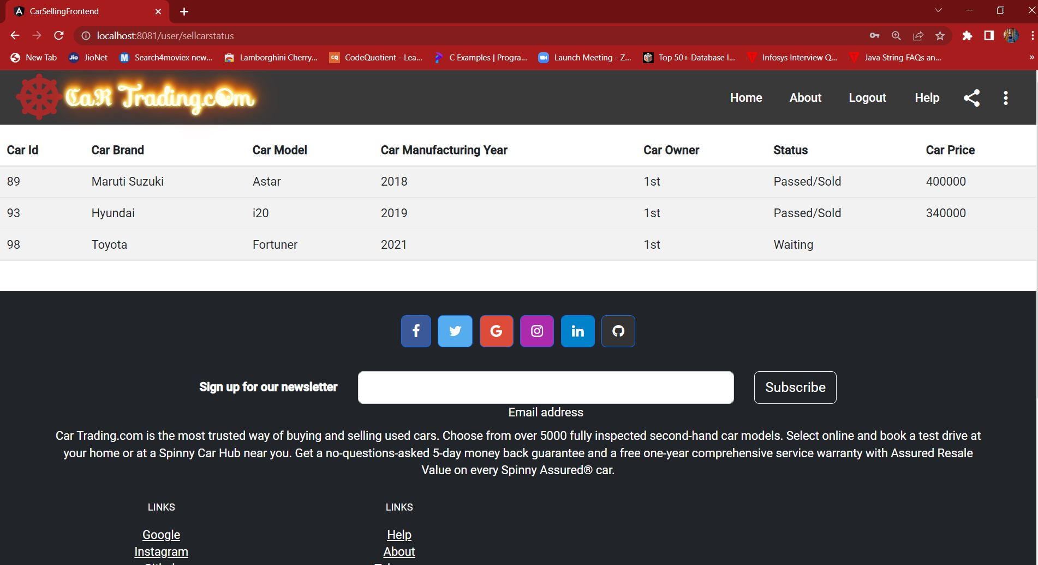

6. User can also buy a car by clicking on “buy car”. When user scroll down, user can see a list of second hand cars available. **Note: These are the cars which are listed by the user’s by clicking on sell car. User can also see his sold car if it is approved by the admin.** These are the cars that are approved by the user. If you are running this application at the first time, then you will not see any car. If the cars are not in the database you can’t see anything. 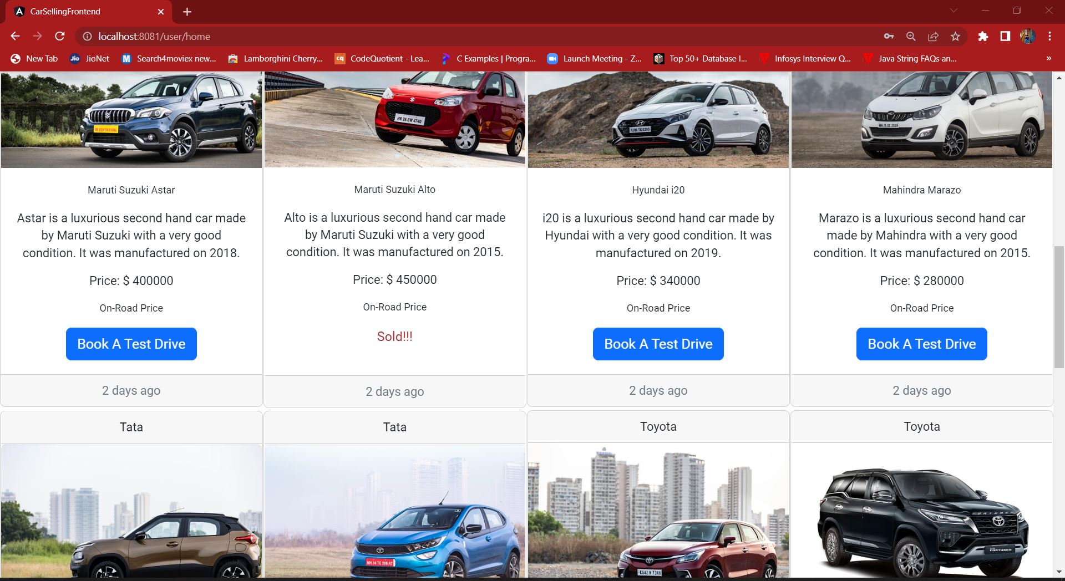

If the car is approved by the admin only then you can buy a car. Otherwise you can only see the car.

**Admin Side:**

After using the user side, you can go to explore admin side. For that, first you have to logout then it will redirect you to the first landing page. There we have to first register as a admin. For that, use username as ***“admin@123”*** while registering. Then only you can be registered as a admin. After that login as a admin. The admin page will look like:

On the admin side, there will be total three tabs. The first one is to view cars which are yet to be accepted/approved. Only admin can accept/reject the car based on the inspection which is done on the field.

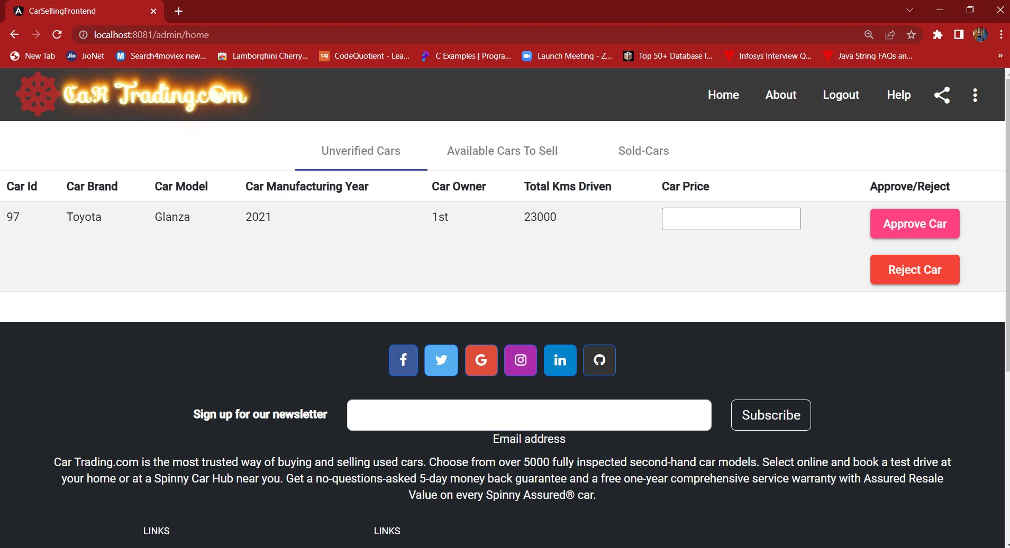

The second tab shows the list of the cars which are accepted but yet to be sold and are listed over the website to be sold. If they are sold admin can mark them as sold.

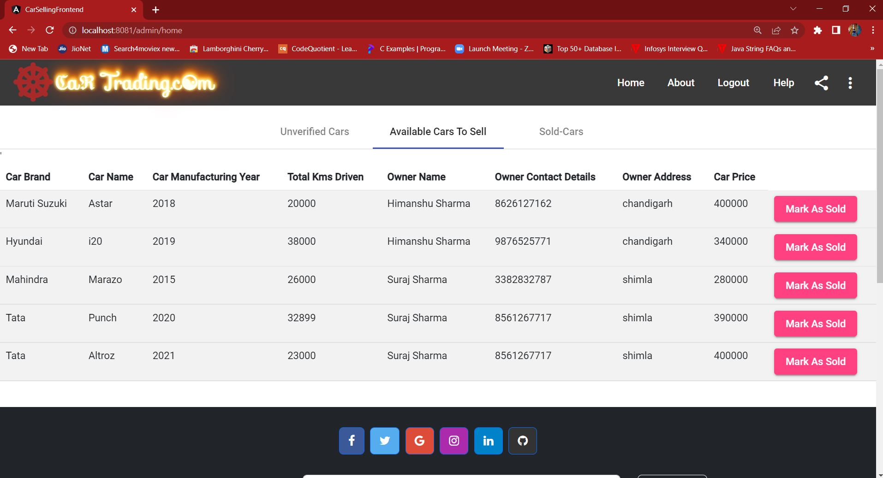

The third tab show the list of cars which are sold.

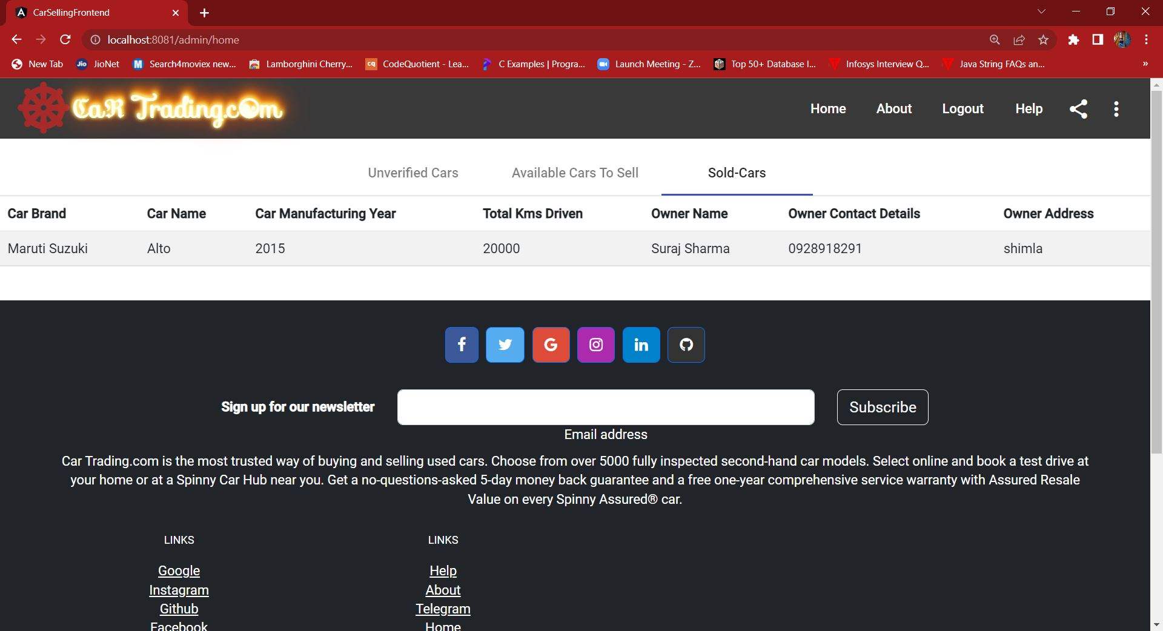

That’s all the one can explore in this project. Apart from this there are many other features which can be added in future.

“***Thank You”***